AGENDA/NOTICE

IDEA Committee Meeting
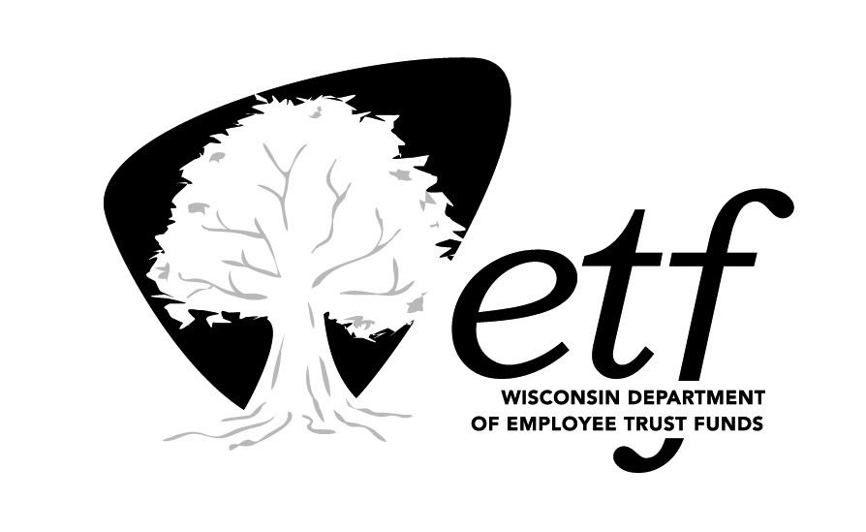
Department of Employee Trust Funds, State of Wisconsin

Monday, December 14, 2020
1:30 PM – 3:00 PM

Remote (Microsoft Teams)
Join Microsoft Teams Meeting

IMPORTANT NOTICE
Workgroup members will be attending this meeting via teleconference. This is a virtual meeting. Public can access the meeting only via teleconference. No physical access will be available.

Please call (608) 266-8585 for assistance with accessing this meeting.

Estimated Time | Topic | Presenter
1:30 pm | Call to Order | Olga Bilinson
1:35 pm | Equity & Inclusion Plan Update | Olga Bilinson/ Korbey White/ Renee Walk
1:50 pm | Diversity Book Club Update | Renee Walk
1:55 pm | Next Year Planning and Organization  Discussion of workgroups/sub-committees | Korbey White  Olga Bilinson  Renee Walk
2:30 pm | Lincoln School—Update & Ideas | Gamze Ligler
2:45 pm | Future Training Update | Korbey White
2:50 pm | EIO Report | Olga Bilinson
2:55 pm | Approval of Minutes: August 2020  Approval of Minutes: October 2020 | Olga Bilinson
3:00 | Adjourn

Documents for this meeting will be shared electronically. A copy of the agenda is posted at the State Capitol and the Department of Employee Trust Funds website.

