AGENDA/NOTICE

IDEA Committee Meeting
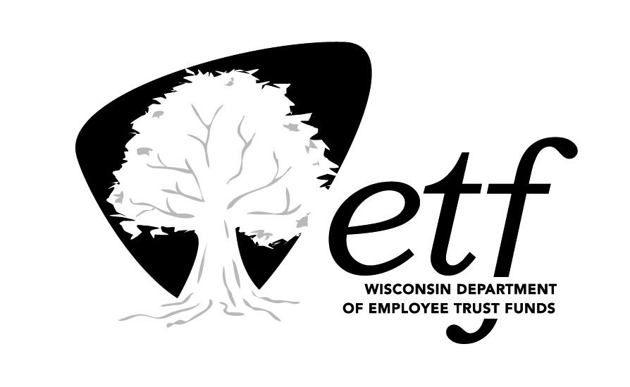
Department of Employee Trust Funds, State of Wisconsin

Tuesday, August 29, 2023
9:00-10:00 am

Remote (Microsoft Teams)

Estimated Time | Topic | Presenter
9:00 am | Call to Order | Patty Zallar
9:05 am | ETF Community Articles & Observance Calendar  S:\Communications\OfficeOfCommunications\Collaboration\ETF Community\ETFCommunityPlanner.xlsx | Brenda Powles & Jen Bronsdon
9:15 am | E&I plan | Brenda Powles
9:35 am | Staff Networking Groups (SNG) | Korbey White
9:40 am | Community Engagement  - Back to School events  - Highway clean up  - Other community events | Korbey White  Team
9:45 am | Approval of Minutes: July 2023  S:\Work_Groups\Committees\IDEA\MINUTES\2023\2023-07-13 IDEA Committee Minutes.docx | Patty Zallar
9:50 am | Other items | Team
10:00 am | Adjourn | Patty Zallar

