AGENDA / NOTICE

**Audit Committee**

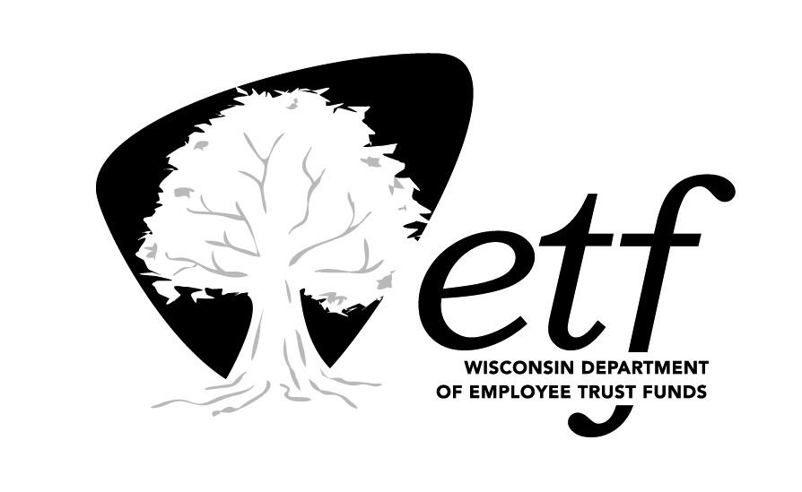Employee Trust Funds (ETF) Board

State of Wisconsin

Thursday, September 21, 2017 (8:00 a.m.)

State Revenue Building – Room 1N-04

2135 Rimrock Road, Madison, WI 53718

| Estimated Time | gavel**Action Item** | Topic |  |
| --- | --- | --- | --- |
| 8:00 a.m. |  | Call to Order |  |
|  | Gavel image | [Consideration of June 22, 2017 Open and Closed Session Meeting Minutes](http://etf.wisconsin.gov/boards/agenda-items-2017/etf0921/audit/item1.pdf) | |
|  |  | 1. **Announcements** |  |
|  |  | 1. **Third Party Administrator Audits** 2. [Pharmacy Benefit Manager](http://etf.wisconsin.gov/boards/agenda-items-2017/etf0921/audit/item3a.pdf) 3. [Total Administrative Service Corporation (TASC)](http://etf.wisconsin.gov/boards/agenda-items-2017/etf0921/audit/item3b.pdf) | Jeff Bogardus (or Eileen Mallow)  Amelia Slaney |
|  | Gavel image | 1. [Review and approve Audit Committee Charter](http://etf.wisconsin.gov/boards/agenda-items-2017/etf0921/audit/item4.pdf) | Yikchau Sze |
|  |  | 1. [Review Internal Audit Charter](http://etf.wisconsin.gov/boards/agenda-items-2017/etf0921/audit/item5.pdf) | Yikchau Sze |
|  |  | 1. [Internal Audit Report - Death Benefit and Distribution](http://etf.wisconsin.gov/boards/agenda-items-2017/etf0921/audit/item6.pdf) | Rick Onasch |
|  |  | 1. [FY2017 - FY2018 Audit Plan Status, including Open Issues Report](http://etf.wisconsin.gov/boards/agenda-items-2017/etf0921/audit/item7.pdf) | Yikchau Sze |
|  |  | Future Items for Discussion |  |
| 8:55 a.m. | Gavel image | Adjournment |  |

## *Please note items may be taken in order other than listed.*

## *Unless otherwise noted, the presenters are ETF staff.*