AGENDA

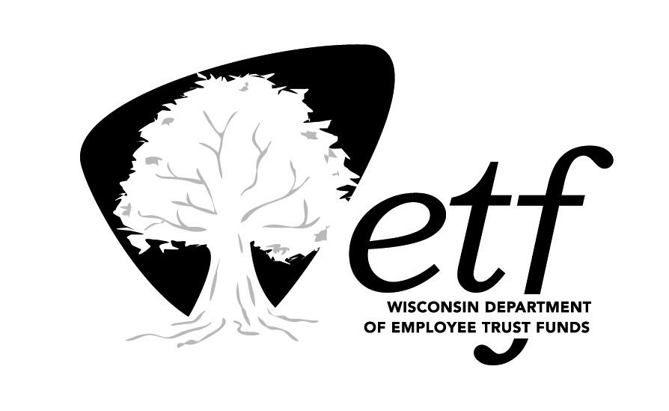
Deferred Compensation Board
Investment Committee (DCIC)
State of Wisconsin

Tuesday, May 17, 2016
1:00 p.m. – 2:00 p.m.

State Revenue Building
Conference Room 1N-04
2135 Rimrock Road, Madison, WI 53713

Estimated Time |  | Topic
1:00 p.m. |  | Call to Order
1:00 p.m. |  | Investment Performance Review as of March 31, 2016 | Bill Thornton, Advised Assets Group
1:25 p.m. |  | WDC Investment Offering Considerations: Federated U.S. Government Securities Fund: 2-5 Years and Stable Asset Fund
1:55 p.m. |  | Future Items for Discussion
2:00 p.m. |  | Adjournment

Times shown are estimates only.

Please note items may be taken in order other than listed. Unless otherwise noted, the presenters are ETF staff.

NOTE: A quorum of the Deferred Compensation (DC) Board may be in attendance at the DCIC meeting. The DC Board will not be conducting business.

