AGENDA / NOTICE

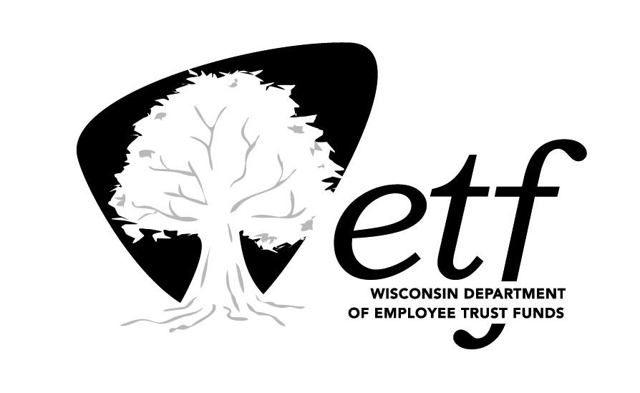
Deferred Compensation Board
Investment Committee (DCIC)
State of Wisconsin

Tuesday, August 23, 2016
1:00 p.m. – 2:00 p.m.

State Revenue Building
Conference Room 1N-04
2135 Rimrock Road, Madison, WI 53713

Estimated Time |  | Topic
1:00 p.m. |  | Call to Order
1:00 p.m. |  | Investment Performance Review as of June 30, 2016 | Bill Thornton,  Great-West Financial
1:20 p.m. |  | Short Government Fund Options | Bill Thornton,  Great-West Financial
1:35 p.m. |  | Large Cap Value Fund Options | Bill Thornton,  Great-West Financial
1:50 p.m. |  | Future Items for Discussion  BlackRock’s Collective Trust Funds  Fidelity Contrafund: Collective Investment Trust Proposal | All
2:00 p.m. |  | Adjournment

Times shown are estimates only.

Please note items may be taken in order other than listed. Unless otherwise noted, the presenters are ETF staff.

NOTE: A quorum of the Deferred Compensation (DC) Board may be in attendance at the DCIC meeting. The DC Board will not be conducting business.

