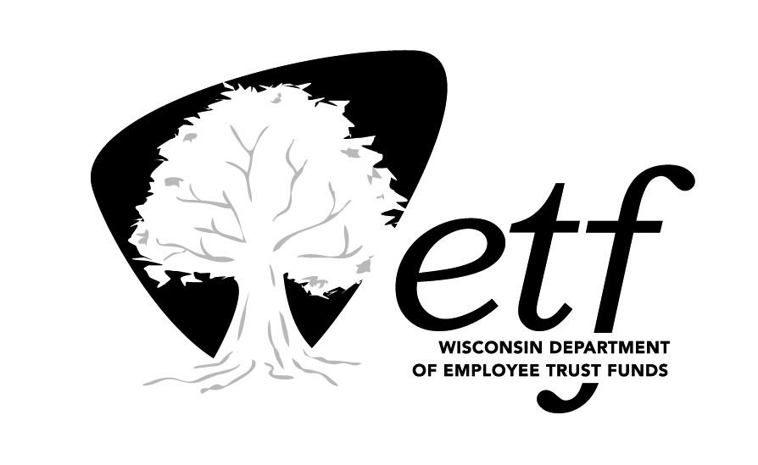 | STATE OF WISCONSIN  Department of Employee Trust Funds  Robert J. Conlin  SECRETARY | 801 W Badger Road  PO Box 7931  Madison WI 53707-7931  1-877-533-5020 (toll free)  Fax (608) 267-4549  http://etf.wi.gov

Correspondence Memorandum

Date: September 21, 2017

To: Deferred Compensation Board

From: Shelly Schueller, Director
Wisconsin Deferred Compensation Program

Subject: Operational Updates

The following items are included with the Board materials for October 16, 2017:

Wisconsin Deferred Compensation Program Information
- List of Fiduciaries, August 2017
- WDC MoneyTalks newsletter, July 2017
- ET-8904: WDC Fact Sheet (revised August 2017)
- “Don’t Give Up Before You’re Finished” postcard samples
- NAGDCA Issue Brochure, June 2017: Cybersecurity
- Empower
  - Q2 2017 Legislative and Regulatory Update
  - Plan Fee Disclosure as of June 30, 2017

Investment Providers

- Federated: Todd Abraham added as a co-portfolio manager
- Galliard: State of Wisconsin Portfolio Review
  - Portfolio Commentary - 2Q17
  - Stable Value Fund Overview – 2Q17
  - Portfolio Review – 2Q17
- Schwab: 2Q17 PCRA Quarterly Report
- Vanguard: Vanguard announces leadership changes, proxy filing – July 13, 2017

Plan Reports
- Selected Quarterly 2017 WDC Statistics (including hardship withdrawals)
- Quarterly Plan Status – 2Q17
- Performance Standards Report – 2Q17

Media Articles
- Camilla Hodgson. “The US filed a $400 billion Libor claim on behalf of 39 banks rescued during the financial crisis.” Business Insider. August 17, 2017.
- M. Arnold, E. Dunkley and P. McClean. “FCA: Libor to end in 2021” Financial Times. July 27, 2017.

