AGENDA/NOTICE

IDEA Committee Meeting
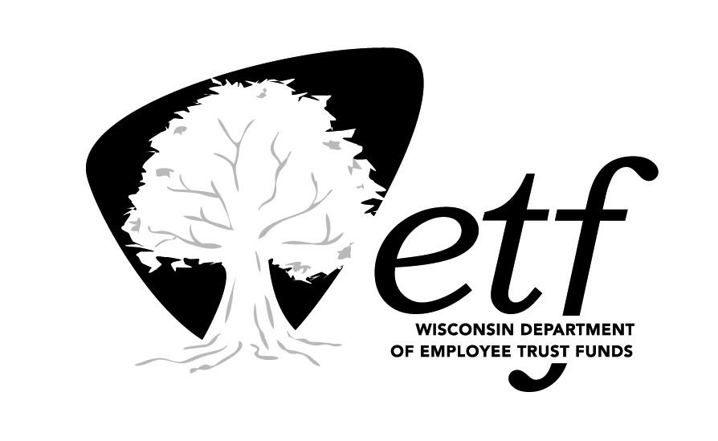
Department of Employee Trust Funds, State of Wisconsin

Friday, December, 2023
10:00 am-11:30 am

Remote (Microsoft Teams)

Estimated Time | Topic | Presenter
10:30 am | Call to Order  - Guest introductions (Brenda) | Alene Kleczek
10:35 am | ETF Community Articles & Observance Calendar  - Community Service (Korbey & Jake)  - Kwanzaa (TBD)  - 12/3: International Day of Persons with Disabilities (Brenda)  - 12/10: 75th Anniversary Universal Declaration of Human Rights (Brenda)  - Released resources (Brenda) | Brenda Powles & Jen Bronsdon
10:45 am | E&I plan update | Brenda Powles
11:15 am | Staff Networking Groups (SNG) | Korbey White
11:20 am | Community Engagement  - Lincoln School partnership (Brenda) | Everyone
11:25 am | Other Items:  - Approval of Minutes: October 2023  - Personnel:  - Outgoing members  - New members  - Officer elections in February  - Open floor | Alene Kleczek
11:30 am | Adjourn | Alene Kleczek

