Box Registration and Troubleshooting Guide

# Objectives

1. How to create an account in Box.
2. How to access ETF-provided documents.
3. How to troubleshoot common Box issues.

# Introduction

Box is a document collaboration tool the Wisconsin Department of Employee Trust Funds (ETF) uses to share files with external parties. If you are receiving electronic files from ETF, you will be asked to register for a free Box account to access your document in Box.

# Creating Your Free Box Account

1. Click [here](https://account.box.com/signup/n/personal#yxnde) to open the Box Individual page.

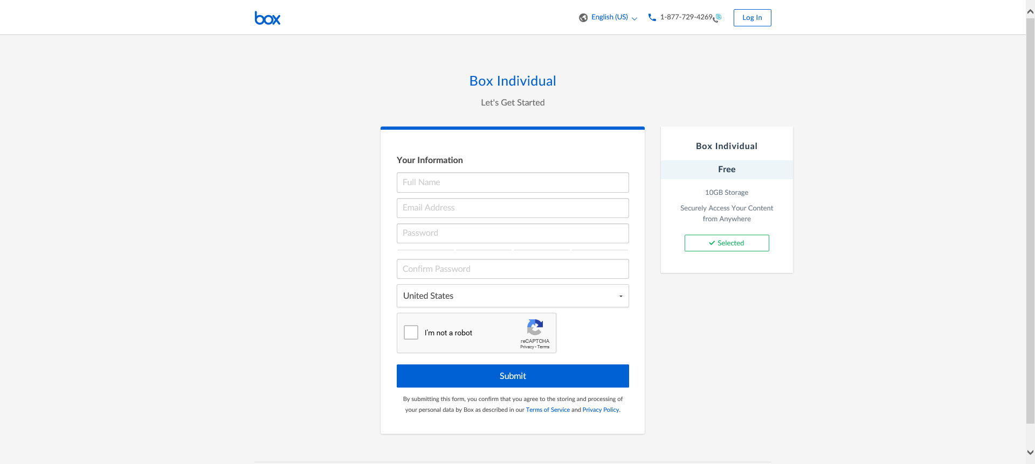

1. Fill out all of the information.

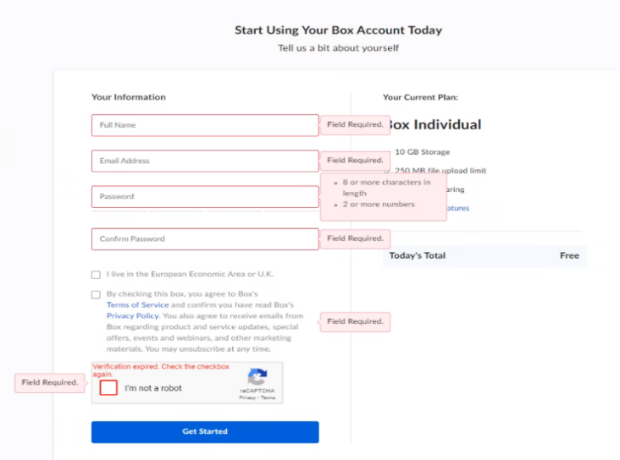

|  |  |
| --- | --- |
| C:\Users\kruchbxknx\AppData\Local\Microsoft\Windows\INetCache\Content.Word\info-icon.png | **Note:**  Make sure you sign up using your email address that you use to communicate with ETF. |

|  |  |
| --- | --- |
| C:\Users\kruchbxknx\AppData\Local\Microsoft\Windows\INetCache\Content.Word\info-icon.png | **Important:** Make sure you verify your email address with Box within 3 hours. The verification link will expire, and you will need to reset your password to be able to access your document. |

1. Open your email and respond to the “Please complete your Box signup” email by selecting the Verify Email button. 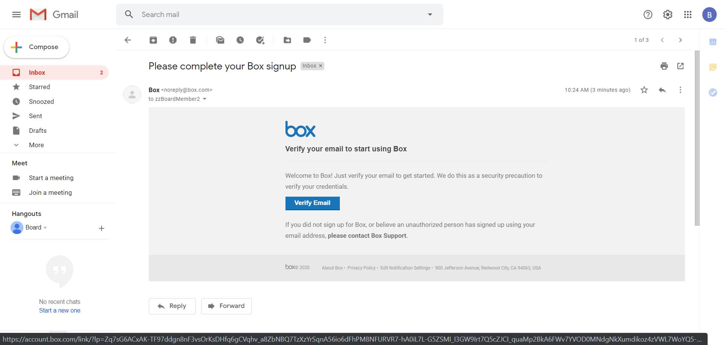

# Accessing Your Document in Box

Once the sign-up process is completed and you have confirmed your email with Box, you will receive an email from BOX with an ETF staff member inviting you to work together on the file. The email will have an individual’s name and is not SPAM. This email will have the link to your requested document. Here is a sample:



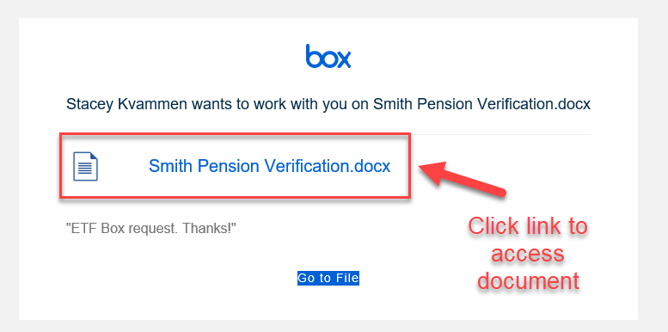

1. If presented with the following screen, select “Not a part of Wisconsin Department of Employee Trust Funds?” since you are not an ETF employee.

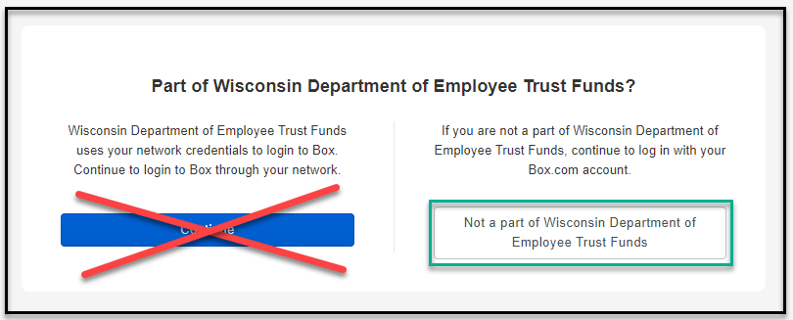

1. Sign into your account:

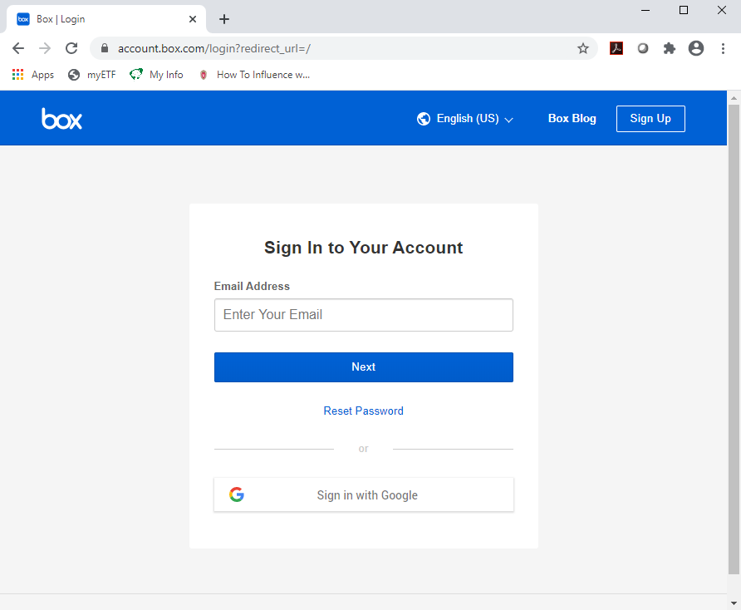

1. Once signed in, your document will be displayed.

# Troubleshooting Common Box Issues

1. I am having difficulty logging into my free Box account

* **Did you select “Not a part of Wisconsin Department of Employee Trust Funds”?**



1. I am getting a message that states, “my link has expired”.

* **Has it been more than three hours since Box requested you verify your email?** If so, your verification link has expired, and you will need to reset your password. Visit <https://app.box.com/reset> to enter the email address associated with your Box account. You will receive an email with a link to reset your password.

1. I completed setting up my free Box account, but I am unable to see my document.

* **Has it been more than one week from your original request?** If so, your document is no longer available, and you will need to request again.
* **Did you use the same email address as you provided when making the request?** If not, please login to Box using this email address.
* **Have you waited 4 hours to give ETF time to process your request?** If yes, please contact ETF at 877-533-5020.
* **Did you receive and follow the link from the second email from ETF?** If not, be sure to check spam or junk folders if the email is not located in your inbox.

1. My password isn’t working and needs to be reset.

* **Look for “Reset Password” when signing into your account and follow the prompts 