RFP ETI0003 – Professional Staffing Services

Vendors planning to submit proposals for the above named RFP must fill out and submit this Appendix 14 to ETFSMBProcurement@etf.wi.gov by the deadline. Do not mail.

Request Type
Secure File Transfer Protocol (SFTP) provides electronic transmissions of data. To ensure you have capabilities to perform SFTP transmissions, you should discuss the system requirements with your information technology department. Please make sure you will be able to send data even if you have a firewall on your system.
Add SFTP Server Access for:
☐ Vendor requesting access for proposal submission

Requester Information
Vendor Name and Address Click or tap here to enter text.
Proposal Contact Name Click or tap here to enter text.
Proposal Contact Email Click or tap here to enter text.
Proposal Contact Phone Number Click or tap here to enter text.

ETF will issue Vendor’s designated Proposal Contact a Logon ID and password to gain access to the system. Here are Vendor Directions for uploading files.
For ETF Use Only: ETF BCAP Requester: Kristen Schipper

ETF Security Administrator Use Only

Click or tap here to enter text.
Logon ID

Click or tap here to enter text.
ETF Security Administrator Signature/Date

Click or tap here to enter text.

Vendor Directions

Step 1 – Activate Your IAM Account
Access to ETF’s SFTP server requires an Identity and Access Management (IAM) account. You will need to activate your IAM account before you can access the SFTP server.

Click the IAM Site Link: https://eiam.wisconsin.gov

Enter the IAM logon ID and temporary password provided to you to establish a new password.
Remember or note your new password.

Follow the steps below to activate your new IAM account by resetting the password and setting up self-service questions. Below link has the guide with step-by-step instructions.

IAM User Setup Guide: http://etf.wi.gov/employers/IAM-EndUserGuide-ETFExternal.pdf

Step 2 – Logon to the SFTP Server
Files must be uploaded using Chrome or Firefox web browsers, please note IE is not compatible.
- Open the browser and navigate to https://mft.etf.wi.gov, then logon using your IAM logon ID and new password.

- By default, you will be taken to the below screen, double click on Home Folder to be taken to the folder formatted ETI0003.
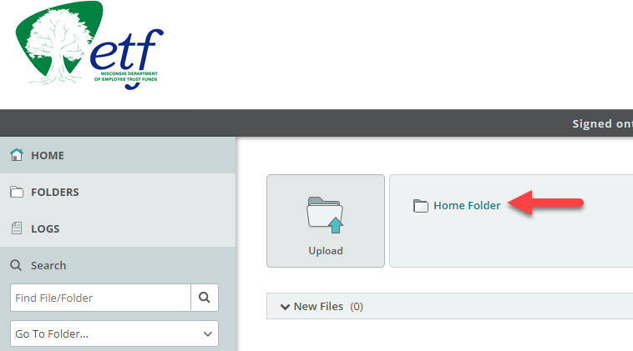

3. Double click on the ETI0003 folder to be taken to the appropriate RFP folders such as Proposal, Redacted Proposal and Cost Proposal.
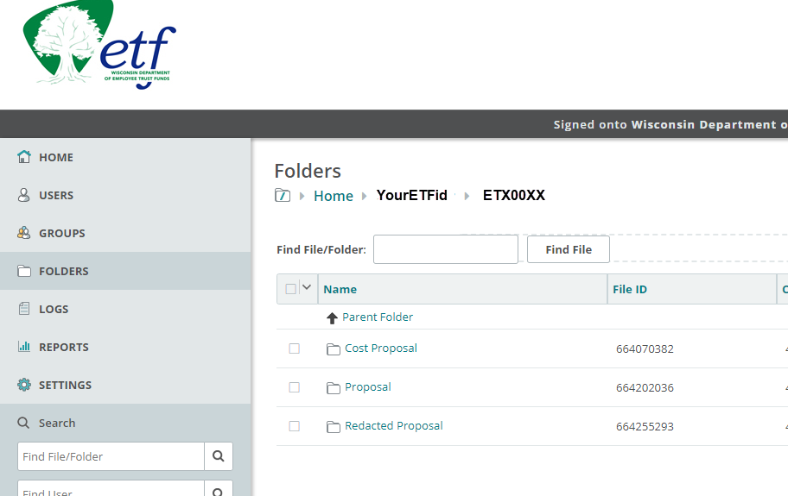

4. After navigating to the correct folder, click the Upload Files button. 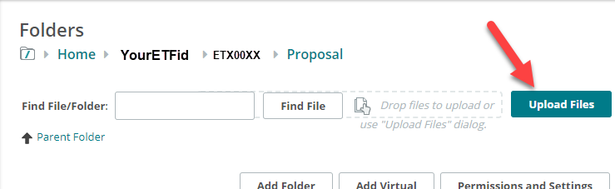

5. Either drag and drop your file(s) onto the Upload Files window or click the Browse link to locate your file to upload. Finally, click the Upload button. After uploading your file, click the Close button.
