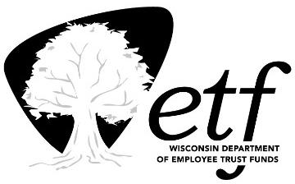

April 21, 2021

STATE OF WISCONSIN
Department of Employee Trust Funds
A. John Voelker
SECRETARY
PO Box 7931
Madison WI 53707-7931

1-877-533-5020 (toll free)
etf.wi.gov

Abstract of Vendors Responding to the Wisconsin Department of Employee Trust Funds’ (ETF) Request for Information (RFI) ETA0043: Medicare Advantage Group Health Insurance Program

RFI responses were received from the following vendors:

- Aetna
- Anthem Blue Cross and Blue Shield
- Dean Health Plan
- HealthPartners
- Humana
- Medica
- Network Health
- Quartz
- Sierra Health and Life Insurance Company, Inc. (UnitedHealth Group)
- Willis Towers Watson US LLC

RFI ETA0043 was issued solely for informational and planning purposes and does not constitute a solicitation. Vendors who responded to the RFI were not offered a contract or contacted by ETF or the State of Wisconsin to form a binding contract for any services.

The listing of vendors above is in alphabetic order and does not reflect any ranking. Abstract list verified by:
Beth Bucaida
Contracts Specialist
beth.bucaida@etf.wi.gov 608.267.3933

