State of Wisconsin
Department of Employee Trust Funds
4822 Madison Yards Way
Madison, WI 53705-9100
P. O. Box 7931
Madison, WI 53707-7931

Date: June 12, 2024
To: All Vendors
Subject: Request for Information (RFI) ETE0062 for Access and State Maintenance Plan, and Local Group Health Insurance Program

Responses are Due by: 2:00 p.m. central time on Wednesday, July 31, 2024

The Wisconsin Department of Employee Trust Funds (ETF) is issuing this Request for Information to solicit input from parties interested in the following State of Wisconsin Group Health Insurance Programs:

- Access and State Maintenance Plan (SMP)
- Local Group Health Insurance Program (for non-State Agencies)

Thank you in advance for your response. Respectfully,

Beth Bucaida, JD/MBA
Contracts Specialist-Advanced
Department of Employee Trust Funds
ETFSMBProcurement@etf.wi.gov

Wisconsin Department of Employee Trust Funds
Request for Information ETE0062
Access, SMP, and Local GHIP

1.1 INTRODUCTION
The purpose of this Request for Information (RFI) is to solicit information from health plan vendors who possess the resources and expertise to provide uniform health benefits. There are two parts to this request. The first is regarding a segment of our population located nationwide and in specific counties spread across the state of Wisconsin. These state and local employees and retirees participate in either the Access Plan or State Maintenance Plan (SMP), which are part of the Group Health Insurance Programs (GHIP). The second part is regarding employees and retirees of participating local governmental entities who have not selected the Access or SMP plans. All plans are fully insured and managed by the Wisconsin Department of Employee Trust Funds (ETF) with oversight by the Wisconsin Group Insurance Board (Board).
This RFI seeks to identify market segment models and recommendations to support value-based plan designs and other innovative cost control options while offering members access to a variety of providers and facilities.
General Information:
- Responses to this RFI will not be returned and become ETF’s property upon submission to ETF.
- Responses to this RFI will not be published by ETF but may be shared with the Board’s consulting actuary (Segal) or with other third parties if requested through a public records request. Therefore, DO NOT INCLUDE ANY CONFIDENTIAL OR PROPRIETARY INFORMATION in your response.
- Responses are voluntary and shall not bind either the respondent or ETF in any way. This RFI is issued solely for information and planning purposes and does not constitute a solicitation.
- Responses to this RFI are not an offer and cannot be accepted by ETF to form a binding contract.
- ETF will not respond to vendor questions regarding the contents of this RFI; include any assumptions you make regarding the subject matter of this RFI in your response.
- Responses to this RFI will be reviewed by ETF and may be used to further develop, change, alter or delete specifications, terms, or conditions within a future solicitation.
- Providing a response to this RFI is not a prerequisite to submitting a proposal should ETF offer such an opportunity in the future. The contents of responses to this RFI will not be considered in the review or evaluation of future bids or proposals.
- ETF is not liable for any cost incurred by any vendor who responds to this RFI.
- ETF may ask respondents to clarify responses.
1.2 BACKGROUND
The Department of Employee Trust Funds (ETF) administers the Wisconsin Retirement System (WRS), the Group Health Insurance Program (GHIP) for State of Wisconsin (State) employers and many local government entities, and a variety of other public employee benefit programs. The WRS has consistently ranked among the top 10 largest public pension funds in the United States, providing retirement benefits for more than 678,000 current and former State and local government employees and their families on behalf of more than 1,500 employers. Participants in the WRS include public school teachers, current and former employees of State agencies and the Universities of Wisconsin, and employees of most State and local governments. All State WRS Members and those from participating local employers are eligible to enroll in the GHIP.
The GHIP makes up one of the largest health plan groups in Wisconsin, spending $1.86 billion in health insurance premiums annually. The GHIP is administered by ETF and 11 (currently) contracted health plans and is a fully insured plan for employees and retirees of State agencies, the Legislature, the Universities of Wisconsin, University of Wisconsin Hospital and Clinics, over 400 local employers, and their dependents.
The SMP offers the same Uniform Benefits* package as the GHIP health plans but is available only in those counties that do not have a qualified Tier 1 health plan. In 2025, 41 out of 72 Wisconsin counties will be covered by the SMP (see Figure 1 below).
*Uniform Benefits refers to the benefits described in the Certificate of Coverage (ET-2180).

Figure 1 shows the different SMP counties in 2024 and 2025.
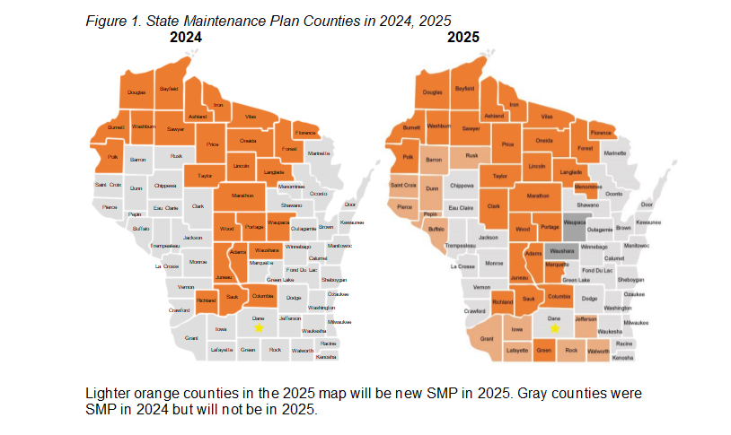

In 2024, SMP enrollment for SMP local employers is approximately 1,200 throughout the state.
The Access Plan permits state and local members to receive care from any qualified healthcare providers nationwide, or during worldwide travel, for treatment covered by the plan. The plan is currently a Preferred Provider Organization (PPO) with approximately 4,305 enrolled members. The in-network PPO benefit is Uniform Benefits.
ETF is exploring interest in options for the Local GHIP. Currently, 11 plans compete for approximately 33,000 members (see Table 1 below). Most of these plans are HMOs that determine which providers will be in-network and available to members. ETF is considering changing this model to either a sole-source statewide vendor or regionalized vendors. A sole-source vendor or regionalized vendor pool may provide an opportunity to explore value-based plan designs and other innovative cost control options.
Segal (the Board’s actuary) and ETF used the Board’s health care data warehouse to compare State and local Per Member Per Month (PMPM) claim costs, geographic cost differences, member ages, and risk scores. The data covered twelve months, ending November 2023. Data was analyzed by county, grouped into six regions, and in total (see Figure 2 below).

Figure 2. Map of Local GHIP Regions Used for Analysis
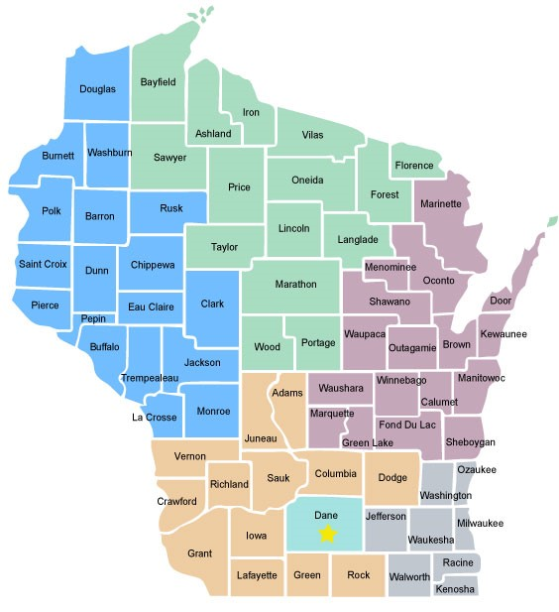

Local GHIP findings include:
- Local members have a PMPM claim cost 3.32% lower than state.
- Local members are slightly younger than state members.
- Local risk scores are comparable to state but are worse by 1%.

Table 1 below shows membership and the percentage of difference in PMPM claim costs compared to the State group from both a proposed regional perspective and in total. ETF is open to recommendations for different regions.

Table 1. Local GHIP Regional Comparison, 12 Months Ending November 2023

Region | Local Members | PMPM % diff from State
Southern | 10,415 | -2.52%
Northern | 1,158 | -6.01%
Western | 2,712 | -14.24%
Northeastern | 5,008 | -3.07%
Southeastern | 5,687 | -7.75%
Dane | 8,037 | -2.17%
Total | 33,017 | -3.32%

2. SUBMITTING A RESPONSE
a. Due Date and Time: Responses are due no later than 2:00 pm central time, on Wednesday, July 31, 2024. Although responses are due by July 31, feel free to submit your response earlier if it is ready prior to the deadline.
Responses submitted after the due date and time listed above may not be reviewed by ETF.

b. Submission of Responses: Responses must be submitted via Box. Upload your responses to the following Box URL link: ETF RFI ETE0062

IMPORTANT:
- Do not upload folders to the above-listed URL. Do not upload zipped folders or zipped files to the above-listed URL.
- Acceptable file types include PDF, DOCX, or XLSX.
- The maximum individual file size is 15 GB.
- Responses to questions, including marketing, promotion, and supplemental materials, should not exceed a total of 25 pages.
- Do not lock or password protect any uploaded files.
- Files must be free of all malware, ransomware, viruses, spyware, worms, Trojans, or anything that is designed to perform malicious operations on a computer.
- If you experience problems accessing Box to upload your documents, please consult with your IT department; consider “whitelisting” Box or turning off your VPN to allow uploads. Box is free and you don’t need to establish an account to upload files.
- If you experience any issues submitting your response to the above-listed Box URL, send an email to ETFsmbProcurement@etf.wi.gov, include “RFI ETE0062” in the subject line.
- All uploaded files must include the respondent’s company name as the first word of the file name.

3. INFORMATION REQUESTED
Vendors submitting a response to this RFI should answer the questions below. Please keep your responses to questions, including marketing, promotional, and supplemental materials, to a total of 25 pages or less.

Answers should only apply to your health insurance coverage for the SMP, Access Plan, or Local GHIP segment of our population unless otherwise specified. ETF is particularly interested in learning about unique or creative approaches to providing broad access to providers and facilities without driving up costs for members in remote or limited access areas of the State.

When considering responses, the Access Plan would be administered by a single vendor. The Local GHIP and SMP could each be administered by a single vendor statewide (sole vendor) or could be separated into regional coverage (regional vendors).

For the Access Plan, include any additional information about your nationwide network. For SMP and the Local GHIP, include any additional information about your network throughout the State and your services.

When responding, indicate if you are considering the Access Plan, SMP, Local GHIP, or a combination of any of these plans.

3.1 COMPANY INFORMATION
3.1.1 Briefly introduce your organization, your experience in administering group health insurance plans with a regional and/or nationwide network (e.g., background, year established, parent company, size, number of customers, offices, number of employees, etc.). Please include ownership structure.
3.1.2 Provide contact name(s) and information for the person(s) ETF may contact concerning your responses.
3.1.3 List any relevant web sites for your company and its offerings.

3.2 General Information
3.2.1. Access Plan, SMP, and Local GHIP. For Access Plan, provide a description of your two largest employer groups that offer a PPO with a nationwide network. For SMP and Local GHIP, provide a description of your two largest employer groups that insure members in the State.
Note: ETF will not contact any employers listed.
3.2.2 Access Plan and SMP. The Access Plan is applicable to both State and local members who need a nationwide network. The Access Plan services approximately 4,305 members. The SMP is applicable to both State and local members and is available only in those counties that do not have a qualified Tier 1 IYC Health Plan. The SMP serves approximately 1,400 members currently, though membership can fluctuate significantly depending upon tiering status, particularly in the Local GHIP.
a. How would the Access Plan and SMP network you may propose address any gaps in member or provider coverage (geographical or member-based) in counties served by the Access Plan and SMP? Note that contracting providers outside of Wisconsin, such as in the Upper Peninsula of Michigan, is acceptable to meet this request.
b. What geographic constraints could impact/limit your ability to successfully support the Access Plan and SMP? Are there other barriers that concern you?
c. What resources (e.g., providers, clinics, hospitals, competitive network contracts) would provide the greatest assistance in Access Plan and SMP member access?
3.2.3 Local GHIP. The Local GHIP serves approximately 33,000 members. While the vast majority of members are located in Southern Wisconsin (specifically Dane and Milwaukee Counties), members live throughout the State.
a. How would the Local GHIP network you may propose address any gaps in member or provider coverage (geographical or member-based) in counties served by the Local GHIP? Note that contracting providers outside of Wisconsin, such as in the Upper Peninsula of Michigan, is acceptable to meet this request.
b. What geographic constraints could impact/limit your ability to successfully support the Local GHIP? Are there other barriers that concern you?
c. What resources (e.g., providers, clinics, hospitals, competitive network contracts) would provide the greatest assistance in Local GHIP member access?
d. Would you recommend different regions than appear in Figure 2 above? If so, what would they be?
3.2.4 Cost Management
a. What efforts have you found effective in controlling provider network and member claims costs?
b. How could your plan balance offering benefits at a reasonable cost with statewide and/or broad network access and smaller pockets of membership in some areas?
c. Provide specific examples of health plan network designs that demonstrate how you have worked to deliver an innovative, cost effective, and quality network to populations similar to the SMP and/or Local GHIP. Segment your response by population as appropriate.
d. What alternatives, if any, could you envision or propose for increasing quality and access while controlling costs for counties served by SMP and/or Local GHIP population? Segment response by population as appropriate.
3.2.5 Other Financial Considerations
a. Do you have risk sharing arrangements built into your provider contracting agreements to ensure high quality care will be delivered? If yes, please describe. To what degree are providers at risk and have these arrangements been effective in bringing about higher quality of care?
b. Do you anticipate any financial risk specifically with serving Access or Local GHIP populations, or SMP counties? Explain your thoughts by population.
3.2.6 Access/Local GHIP Centers of Excellence (COE) (answer specifically regarding the Access Plan or Local GHIP)
a. Does your plan designate or recognize COEs? What is your experience with minimum cost differential required and member access to drive utilization of COEs?
3.2.7 Access/SMP/Local GHIP Supplemental Information
a. What program enhancement or other approaches to serve the Access Plan, SMP, or Local GHIP population might you offer to ETF that we have not requested information about? Please provide details. Include information on the following:
i. What do you see as the pros/cons of a sole source versus regional Local GHIP?
ii. If you are considering the regional option, what would you propose as the regions and why?
b. Indicate whether or not your company would consider bidding on a Request for Proposals (RFP) for the Access/SMP Programs and/or for the Local GHIP, if ETF releases a solicitation for those programs. If you would not consider submitting a bid for one or both of these programs, please explain why.
c. List and describe the documentation and data that would be essential for your company to develop a response to an ETF RFP for an Access, State Maintenance Plan (SMP), and/or Local Group Health Insurance Program (for non-State Agencies), if published.

End.

