|  |  |  |
| --- | --- | --- |
| ETF_logo_large | **STATE OF WISCONSIN**  **Department of Employee Trust Funds**  **A. John Voelker**  SECRETARY | 4822 Madison Yards Way  Madison, WI 53705-9100  P. O. Box 7931  Madison, WI 53707-7931  http://etf.wi.gov |

Date: July 2, 2025

To: All Potential Proposers to RFP ETF0060

RE: Addendum No. 2 makes changes to the RFP document, Appendix 4 – Mandatory Qualifications, Appendix 5 – Audit Requirements, and Appendix 10 – Cost Proposal

This Addendum is available on ETF’s web site at <https://etf.wi.gov/node/41766>

**Acknowledgement of receipt of this Addendum No. 2:**

**Proposers should acknowledge receipt of this Addendum No. 2 by providing the information in the table below and including this Page 1 with their Proposal cover letter.**

|  |  |
| --- | --- |
| Company Name: |  |
| Authorized Person Name & Title: |  |
| Date: |  |

**The following edits in red text are hereby made to Appendix 4 and Appendix 5 of the RFP:**

**Appendix 4 – Mandatory Qualifications Section 4.5, 4.6, 4.7 and 4.11**

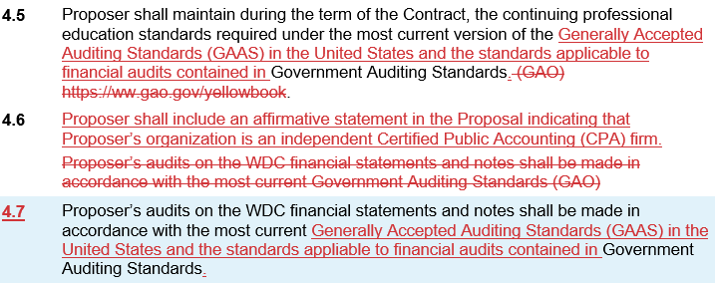

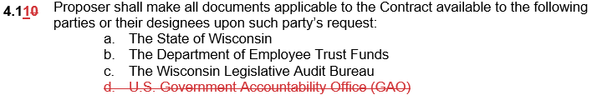

**Appendix 5 – Audit Requirements Section I. Scope of Work**

1. ***Scope of Work***
2. Submit **Initial Draft Report** by April 15 each year, **Final Draft Report** by April 30 each year, and **Final Opinion** **Report** 3 Business Days after Q2 Board meeting each year.

*Contractor shall conduct an examination of the WDC financial statements for the following periods:*

*Audit for the 12 month period ending December 31, 2026 (2026 audit) ~~which includes the comparative statements for the 12 month period ending December 31, 2025;~~*

*Audit for the 12 month period ending December 31, 2027 (2027 audit) ~~which includes the comparative statements for the 12 month period ending December 31, 2026~~; and*

*Audit for the 12 month period ending December 31, 2028 (2028 audit) ~~which includes the comparative statements for the 12 month period ending December 31, 2027~~.*

**The following edits in red text are hereby made to the RFP and Appendix 10:**

**Delete RFP Table 3 – Calendar of Events\***

**Add RFP Table 3 – Calendar of Events**

|  |  |
| --- | --- |
| Table 3 - Calendar of Events\* | |
| Date | **Event** |
| June 17, 2025 | Department Issues RFP ETF0060 (Release Date) |
| July 9, 2025 | Proposer Questions and Letter of Intent Due |
| July 16, 2025 | Department Posts Responses to Proposer Questions |
| August 1, 2025 no later than 10:00 A.M. central time zone (CTZ) | Proposal Due Date |
| September 11, 2025 | Deferred Compensation Board Meeting |
| September 2025eptember 2025 | Notice of intent to award contract published |
| January 1, 2027 | Contract Start Date |

**Delete RFP Section 1.10 Contract Term**

**Add RFP Section 1.10 Contract Term**

The Contract term for providing the Services will commence on January 1, 2027 and extend through December 31, 2029. The Board retains the option, by mutual agreement of the Board and the Contractor, to renew the Contract for two (2) additional two (2) year periods extending the Contract through December 31, 2033, subject to the satisfactory negotiation of terms, including pricing. Contractor’s performance may be reviewed by Board and/or Department staff to inform continuation of the Contract. Prior to each audit, the selected Contractor and Department shall define the statement of work for the upcoming audit.

**Appendix 10 – Cost Proposal**

Revised to emphasize the first audit will happen in the year 2027 and will be auditing the 2026 WDC financial statements and notes.

**END.**